**Experiment No.: 1**

**Aim:** Create a python program to create a package (Engg), sub-package( years),modules (sem) and create staff and student functions to modules.

**CO3:** Design modules and packages - built in and user defined packages.

**Procedure:**

sem.py:

def staff(name):

print("Name of the staff:",name)

def student(name):

print("Name of the student:",name)

call.py:

import Engg.yrs.sem as sem

sem.staff("jeeva")

sem.student("kiran")

**Output Screenshot**

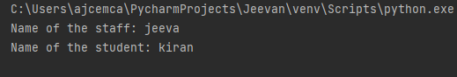

**Result**

The program was executed and the result was successfully obtained. Thus, CO3 was obtained.

**Experiment No.: 2**

**Aim:** Write a Python program to generate a random color hex, a random alphabetical string, random value between two integers (inclusive) and a random multiple of 7 between 0 and 70.

**CO3:** Design modules and packages - built in and user defined packages.

**Procedure:**

import random

import string

print("generate a random color hex:")

print ("#{:60x}".format(random.randint(0,0xFFFFFF)))

print("in generate a random alphabetical string:")

max_length = 255

s= " "

for i in range(random.randint(1,max_length)):

s+=random.choice(string.ascii_letters)

print(s)

print("generate a random value b/w two integers, inclusive:")

print(random.randint(0,10))

print(random.randint(-7,7))

print(random.randint(1,1))

print("generate a random multiple of 7 b/w 0 and 70:")

print(random.randint(0,10)*7)

**Output Screenshot**

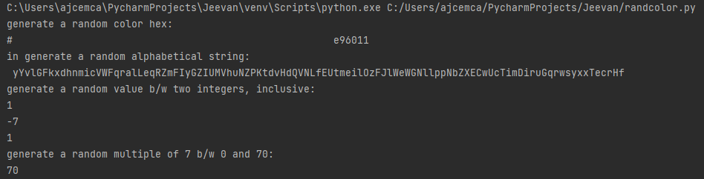

**Result**

The program was executed and the result was successfully obtained. Thus, CO3 was obtained.

**Experiment No.: 3**

**Aim:** To select a random element from a list, set, dictionary (value) and a file from a directory. Use random.choice().

**CO3:** Design modules and packages - built in and user defined packages.

**Procedure:**

import random

import os

print("Select a random element from a list:")

elements = [1,2,3,4,5]

print(random.choice(elements))

print(random.choice(elements))

print(random.choice(elements))

print(random.choice(elements))

print("\nSelect a random elements from a set:")

elements = set([1,2,3,4,5])

#convert to tuple because sets are invalid inputs

print(random.choice(tuple(elements)))

print(random.choice(tuple(elements)))

print(random.choice(tuple(elements)))

print("\nSelect a random value from a dictionary:")

d = {"a": 1, "b": 2, "c": 3, "d": 4, "d": 5}

key = random.choice(list(d))

print(d[key])

key = random.choice(list(d))

print(d[key])

key = random.choice(list(d))

print(d[key])

print("\nSelect a random file from a dictionary:")

print(random.choice(os.listdir("/")))

**Output Screenshot**

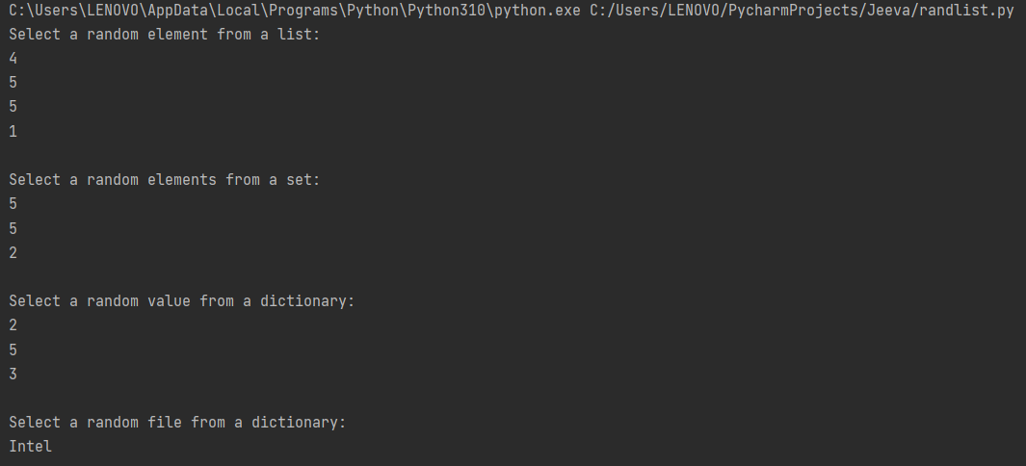

**Result**

The program was executed and the result was successfully obtained. Thus, CO3 was obtained.

**Experiment No.: 4**

**Aim:** Write a Python program to create a list of random integers and randomly select multiple items from the said list. Use random.sample().

**CO3:** Design modules and packages - built in and user defined packages.

**Procedure:**

import random

print("create a list of random integers :")

population = range(0,100)

nums_list = random.sample(population,10)

print(nums_list)

no_elements = 4

print("\nRandomly select",no_elements,",multiple items from a said list:")

result_elements = random.sample(nums_list,no_elements)

print(result_elements)

no_elements=8

print("\nRandomly select",no_elements,"Multiple items from the said list:")

result_elements = random.sample(nums_list,no_elements)

print(result_elements)

**Output Screenshot**

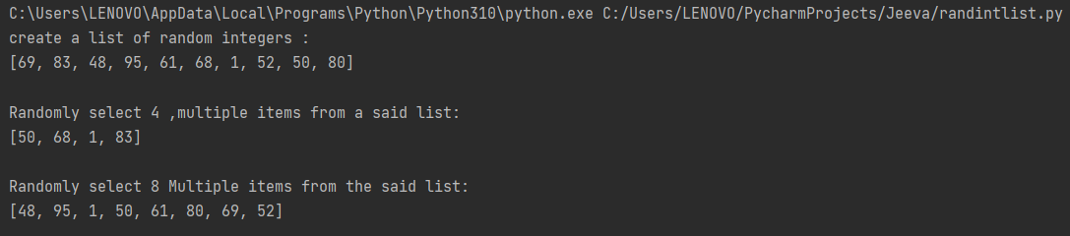

**Result**

The program was executed and the result was successfully obtained. Thus, CO3 was obtained.

**Experiment No.: 5**

**Aim:** Python script to display various date time formats.

**CO5:** Design modules and packages - built in and user defined packages.

**Procedure:**

import time

import datetime

print("Current date and time:",datetime.datetime.now())

print("Current year:",datetime.date.today().strftime("%Y"))

print("Month of year:",datetime.date.today().strftime("%B"))

print("Week number of the year:",datetime.date.today().strftime("%W"))

print("Weekday of the week:",datetime.date.today().strftime("%w"))

print("Day of year:",datetime.date.today().strftime("%j"))

print("Day of the month:",datetime.date.today().strftime("%d"))

print("Day of week:",datetime.date.today().strftime("%A"))

**Output Screenshot**

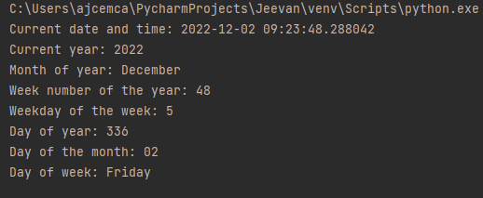

**Result**

The program was executed and the result was successfully obtained. Thus, CO3 was obtained.

**Experiment No.: 6**

**Aim:** Write a Python program to get the current time in Python.

**CO5:** Design modules and packages - built in and user defined packages.

**Procedure:**

import datetime

now = datetime.datetime.now()

print("Current date and time: ")

print(now.strftime("%Y-%m-%d %H:%M:%S"))

**Output Screenshot**



**Result**

The program was executed and the result was successfully obtained. Thus, CO3 was obtained.

**Experiment No.: 7**

**Aim:** Write a python program to subtract 5 days from the current date.

**CO3:** Design modules and packages - built in and user defined packages.

**Procedure:**

from datetime import date, timedelta

dt = date.today() - timedelta(5)

print("Current date:",date.today())

print("5 days before current date:",dt)

**Output Screenshot**



**Result**

The program was executed and the result was successfully obtained. Thus, CO3 was obtained.